Individual Ancestry Estimation
I. Maximum Likelihood Method
We begin by considering a population that was formed by admixture between two genetically distinct ancestral populations. Assuming that evolutionary pressures other than admixture have been insignificant, the frequency of an allele k at an arbitrary locus in the admixed population, p_{Ak}, will be a linear combination of allele frequencies in the ancestral populations, p_{jk},
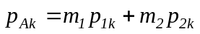, Eq.1
where m_{j} is the proportionate contribution of the j^{th} ancestral population. Since 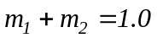, Eq.1 can be written using only one of the ancestral contributions,
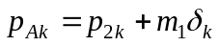 , Eq.2
where 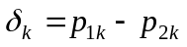is the usual measure of allele frequency difference. Eqs. 1 and 2 apply to all alleles at all loci.
The genetic contributions of the ancestral populations can be estimated by maximum likelihood from a sample of genotypes from the admixed population. Assuming codominance and random mating in the admixed population, the log likelihood for the ancestral contributions at the g^{th} locus is proportional to
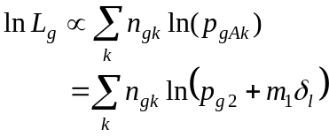 Eq.3
where 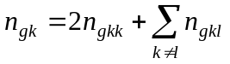and is the count of the allele A_{k}, n_{gkk} is the count of A_{k}A_{k} homozygotes, and n_{gkl} is the number of A_{k}A_{l} heterozygotes. The summation in Eq.3 is taken over all alleles at all loci. Notice that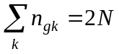 is twice the number of individuals in the sample, and barring missing data, 2N is the same for all loci. The log likelihood across multiple loci is the sum of the log likelihoods for the individual loci, 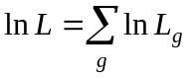. Estimates of individual admixture are obtained by treating each individual as a sample of size one (Chakraborty et al. 1986) because the same likelihood applies to samples of any size.
Differentiating Eq.3 with respect to m₁ gives
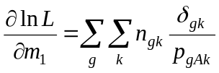 . Eq.4
The maximum likelihood estimate of the ancestral contribution, 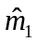, is obtained by setting Eq.4 equal to zero and solving for m₁. This usually requires a numerical procedure, but the problem is not particularly challenging. The expected Fisherian information is obtained from the expected negative second derivative of the likelihood
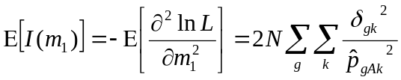 Eq.5
where 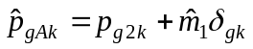 is the expected frequency of the k^{th} allele in the admixed population or individual. Notice that information for ancestry is additive over loci. The expected variance of the admixture estimate is 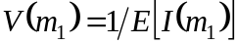 and V(m₂) = V(m₁) because of the relationship m₂ = 1 – m₁.
The model can be expanded to accommodate any number of parental populations. For brevity and concreteness, we consider the case in which three parental populations have contributed to the admixed population such that the frequency of the k^{th} allele in the admixed population is
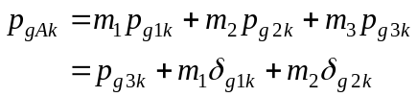 Eq.6
where the ancestral contributions sum to 1.0, and the δ coefficients are defined 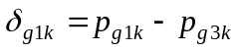 and 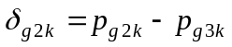. As before, Eq.6 applies to all alleles at all loci. The log-likelihood function remains as in Eq.3,
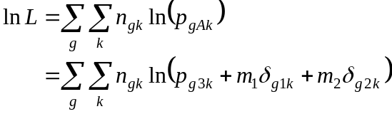 , Eq.7
except that the allele frequency component is expanded as in Eq.6. It is worth noting that the constraint 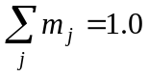 ensures that the outcome of analysis is unaffected by the way parental populations are numbered, or which population is subtracted from the others. Maximum likelihood estimates for the ancestral contributions are obtained from the log likelihood function by the setting partial derivatives,
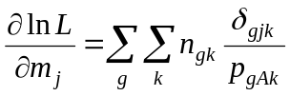 , Eq.8
equal to zero, and solving simultaneously.
The information with respect to the admixture parameters is presented in matrix form. By extension of Eq.5, the information matrix has as its elements the negative expected second partial derivatives of the log likelihood function
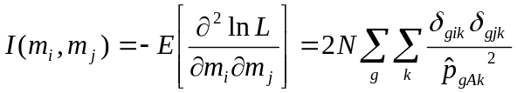 . Eq.9
The element in the i^{th} row and i^{th} column is the expected information for the estimate of the parameter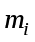and the element in the i^{th} row and j^{th} column is the expected shared information for the estimates of the parametersand 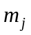. The inverse of the information matrix provides the expected variance-covariance matrix of estimated admixture proportions. As before, for multiple loci the likelihoods and information are summed over all loci.
The inverse of the information matrix provides the expected variances of the estimates along the diagonal and covariances on the off-diagonals. The maximum likelihood estimates for populations 1 and 2 are calculated using Newton-Rhapson method. Begin with estimates of the proportions of admixture for these two populations and calculate eqn. 8, which gives the score vector. The calculate eqn. 9 and take the inverse of it and multiply it by the score vector. The resulting answer is then added to the original estimates used and then these new answers are used as the starting values for the next iteration. Convergence happens when the scores (i.e. eqn. 8) equal zero. The maximum likelihood estimate of 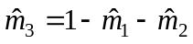and the associated variance is obtained from (Edwards 1992).

References
(1) Stuart A, Ord JK, Arnold S. Kendall’s Advanced Theory of Statistics, Volume 2A, Classical Inference and the Linear Model. Arnold Publishers, London, UK, 1999.
(2) Long JC, Smouse PE. Intertribal gene flow between the Ye'cuana and Yanomama: genetic analysis of an admixed village. Am J Phys Anthropol. 61:411-22, 1983.
(3) Chakraborty R, Kamboh MI, Nwankwo M, Ferrell RE. Caucasian genes in American blacks: new data. Am J Hum Genet, 50:145-55, 1992.
(4) Hanis CL, Chakraborty R, Ferrell RE, Schull WJ. Individual admixture estimates: disease associations and individual risk of diabetes and gallbladder disease among Mexican-Americans in Starr County, Texas. Am J Phys Anthropol. 70:433-41, 1986.
(5) Chakraborty R. Gene admixture in human populations: models and predictions. Yearbook of Phys Anthropol 29:1-43, 1986.
(6) Elston RC. The estimation of admixture in racial hybrids. Ann Hum Genet. 35:9-17, 1971.
(7) Edwards AWF (1992) Likelihood. Johns Hopkins University Press, Baltimore

